Poquito Valley Flood Hazard Study

Elevation Reference Monuments

INDEX MAP

Elevation Reference Marks

POQERM1

VertCon Conversation
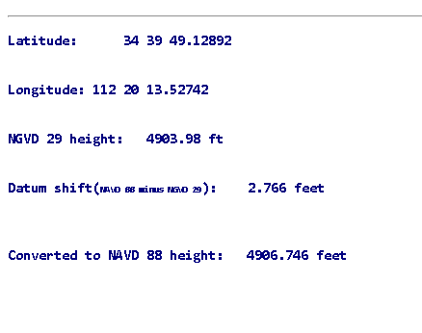

POQERM2

VertCon Conversation
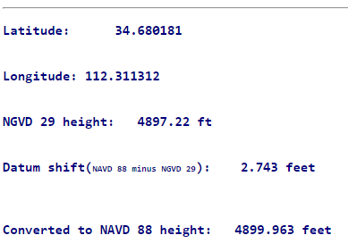

POQERM3

VertCon Conversation
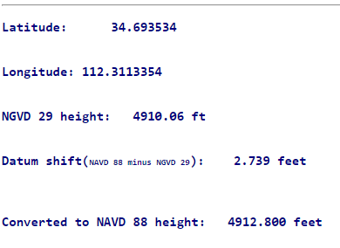

POQERM4

VertCon Conversation

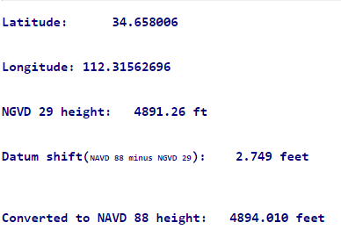

POQERM5

VertCon Conversation
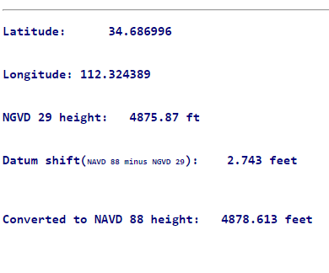

POQERM6

VertCon Conversation
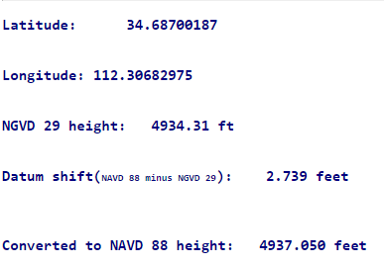

POQERM7

VertCon Conversation
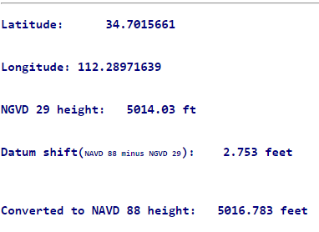

POQERM8

VertCon Conversation
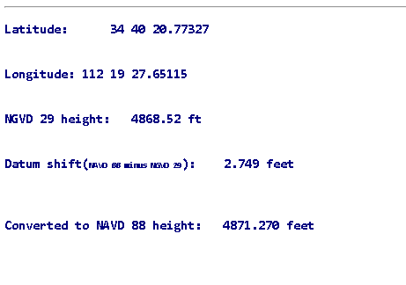

POQERM9

VertCon Conversation
